MHD+ Tuning Guide

Revision 1.37 • 7/24/2025
© MHD Tuning

Table of Contents

Introduction 5
Platform Specific Notes 6
Antilag 6
Main Tables 6
Antilag Timing (Base) 7
Antilag Timing (P-Factor) 8
Antilag Timing Ramp Rates 9
Antilag Boost Target 9
Antilag Fuel Target 9
Turbine I-Factor 10
Antilag Compressor Base / P-factor 10
Safeties 11
Map Switching 12
Operation 12
Table Overview 13
FlexFuel 15
Enabling (with ECA) 15
Enabling (without ECA) 16
Blending / Interpolation 17
Table Groupings 17
Main FF vs. FF2 18
Show the Math! 19
Enable Individual FF#2 Blending 20
Fuel Start and Warmup Enrichment 21
N54 Specific FlexFuel Details 22
Specific Use Cases 23
KnockCEL 24
Main Tables 24
ReFlex Integration 25
Basic Integration 25
Enabling 25
Logging Parameters 26
Safeties 26
Advanced Integration 27
Enabling 27
Enabling - Gen1 B58 Specific 28
Tuning with Automatic Port Injection 28
Automatic PI Tables 29
Low Pressure Fuel Sensor Source 29
Base Fuel Pressure (Low Pressure) 30
Injector Scalar 30
3D Injector Latency 31
Differential Fuel Pressure Compensation 31
Non-Linear Injector Compensation 32
PI / DI Percent Split (Gasoline / Ethanol) 33
Maximum Allowed DI Usage 34
Port Injection Interpolation 35
Minimum Injector Pulsewidth 35
Calculation Output Mode 35
Tuning with Manual Port Injection 36
General Tables 36
Manual Tables 36
Aux Outputs 37
Logging Parameters 38
Safeties 40
New / Custom Tables 41
Boost Ceiling (Relative) (Gear x RPM) 41
N54 Specific Boost Ceiling Details 42
Custom WGDC Control 43
N54 Specific Custom WGDC Control Details 43
MG1 Specific WGDC Control Details 44
Table Axis Details 44
Advanced / Max Effort 45
5 Bar+ Boost Support 45
Sensor Configuration 45
Enable Increased Boost Ceiling Patch 45
MHD+ Load Calculation Config 46
Correcting Load Actual 46
Why Load Reduction Scaling? 46
Properly Tuning Load Reduction Scaling 47
Advanced Logging Params 48
Custom Safeties 49
Enable Conditions 49
Input Sources 49
LPFP Safety 49
Aux 2 Safety 49
EGT Safety 50
Reaction Configuration 50
8HP Transmission TCU 51
Logging Parameters 51
Real-Time Tuning 53
Locking Tune Files with MHD+ Features 54
Revision History 55

Introduction
MHD+ is the overall encompassing name of our suite of custom features we have added to the DME in order to improve and expand upon its functionality. Currently we offer MHD+ support for the following vehicles:
- E-Series (MSD8x DME): N54
- E-Series (MEVD DME): N55
- F-Series (MEVD DME): N13, N55 (PWG and EWG), S55
- F/G-Series (MG1 DME): B58 gen1, B58 gen2, S58
We are working to actively expand MHD+ support to more engines and platforms, both newer and older, so stay tuned! Additionally, the list of MHD+ features will be expanded going forward as well, and we have quite a few exciting additions both planned and in the works.
The MHD+ feature set currently includes the following:
- Antilag
- CAN based Ethanol Content Analyzer (ECA) integration
- Motiv ReFlex integration
- On-the-fly map switching
- FlexFuel
- New / Custom tables
- MHD+ specific custom DTC error codes
For information and tuning help related to the various features, please see their respective sections below.

NOTE:
The empty CAL area we are using for new tables can be set to 0xC3, 0x00, or some other junk data in OEM form (depending on the DME type and ROM version). Please be aware of this. You may start with one of our pre-filled MapSwitchBase bins that will have friendlier values in the tables, or you may copy those changes over to your bin in TunerPro.

Platform Specific Notes
There are some small differences in MHD+ between platforms. This can include the tables provided, axis orientation, implementation details, etc. Also, some platforms needed special conditions added in order to circumvent their unique limitations (like the ~22psi boost cap on N54).
We have done our best to comprehensively detail these differences, exceptions, etc in this document. In each of the below sections, a PLATFORM NOTES comment will expand upon these details. Please feel free to reach out to us if there is something you have a question about or notice it is not covered / detailed, and we will be more than happy to assist.

Antilag
This feature is enabled by setting the Enable Antilag table to 1, while appropriately tuning the below tables. Antilag is then activated in the car (once operating conditions are within the configurable safety limits) by pressing and holding one of the following buttons below, while applying throttle:
- E-Series: pull cruise control stalk in TOWARD you, or hold steering wheel VOL DOWN
- F/G-Series: hold either the cruise control RES button, or the cruise control DOWN rocker switch (both first and second indent work)
PLATFORM NOTES:
- MG1 DME: provides the ability to Enable Antilag per map slot.

Main Tables
Tuning of these tables can greatly vary from car to car due to the exhaust setup, turbo, fuel, etc. The values and screenshots below are meant to be a general guide / starting point. Always log and validate per vehicle.

Antilag Timing (Base)
Timing retard is the main driver in generating exhaust gas energy and heat to get your turbo spooled up. The goal is to retard timing enough to greatly reduce or eliminate the forward acceleration of the vehicle (for rolling use cases, stopped / launch use cases can disregard), while also providing sufficient energy to get the turbo spooled. Similar amounts of timing retard can likely be used for various boost target columns as the DME can regulate boost with WGDC and throttle position as well. While antilag is active, this timing table becomes the new main timing table.
- X-axis: Boost Target (psi, relative)
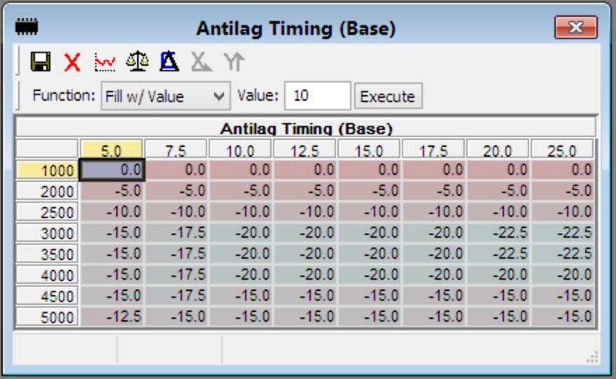
- Y-axis: RPM

PLATFORM NOTES:
- MSD8x DME: the boost target axis features dynamic scaling (when also using the 3-cell TMAP scaling), to allow entering actual boost values past 22psi.
- MG1 DME: the X and Y axis are swapped

Antilag Timing (P-Factor)
This is a simple P-factor table whose output is added to the result of the Timing (Base) table above. Its purpose is to help provide enough timing retard to attain the boost target (for large positive boost deviations), while also providing a safety net to add positive timing in the result of an overboost (negative deviation).
- X-axis: Boost Deviation (psi, relative)
- Y-axis: RPM
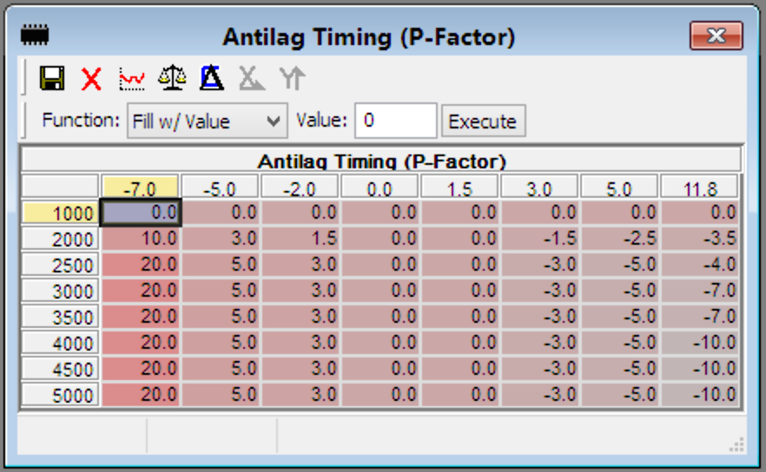
PLATFORM NOTES:
- MSD8x DME: this table is not provided due to free CAL space restrictions
- MG1 DME: the X and Y axis are swapped

Antilag Timing Ramp Rates
The instant antilag is disengaged, ignition timing starts blending back to the values of whichever main DME timing table is currently active (spool, path 1, path 2, etc). These two single cell tables determine that rate. While ignition timing is still negative, the Timing Ramp Rate (°crk < 0) table is used. Once it reaches 0, then the Timing Ramp Rate table is used.
- Timing Ramp Rate: suggested value of 1.5 (°crk/10ms)
- Timing Ramp Rate (°crk < 0): suggested value range of 5 - 10 (°crk/10ms)

Antilag Boost Target
While antilag is active, this acts as a ceiling to boost target. Therefore if the user is only slightly pressing the throttle, it is possible to have a lower target than what is set in this table. The table units are psi, relative.
PLATFORM NOTES:
- MSD8x DME: this table features dynamic scaling (when also using the 3-cell TMAP scaling), to allow entering actual boost values past 22psi.
- MG1 DME: provides configuration boost targets per map

Antilag Fuel Target
While antilag is active, this table becomes the active AFR target for fuel banks 1 (and 2 if appropriate). Leaner values can give even quicker spool, while richer will help keep the EGT cooler. If you are using this to try and keep EGT under the safety value, be sure to log our EGT pre-turbo parameter. While its exact value is not necessarily accurate, the trends are and this is one of the fastest responding EGT parameters the DME has.

Turbine I-Factor
While antilag is active, we selectively enable the I-Factor applied to turbine power (kW). There are three single cell tables: the minimum and maximum bounds of the integration constant sum, and the actual integration constant (amount added or subtracted every 10ms). The intent of these tables is to help with overboosting during antilag, so we recommend setting the Maximum to 0. The Minimum and Constant can be set to 0 if not desired, or tuned accordingly to help keep antilag boost in check.
PLATFORM NOTES:
- MSD8x DME: this table is not provided (was not deemed necessary)
- MG1 DME: this table is not provided (was not deemed necessary)

Antilag Compressor Base / P-factor
These tables are provided to give better boost control during antilag on MG1 DME vehicles. To enable these tables, set the Enable Antilag Compressor Map and P-Fac Tables table to 1, and then fill the Antilag Compressor Map… and Antilag WGDC P-Fac tables accordingly. If you are using our custom WGDC boost control scheme on a supported platform (detailed in the New / Custom tables section of this document), that will override the values in these tables.
PLATFORM NOTES:
- MSD8x DME: these tables are not provided (were not deemed necessary)
- MEVD DME: these tables are not provided (were not deemed necessary)

Safeties
Currently, the following tables are provided in order to ensure a relatively safe usage of antilag. They may be expanded in the future.
- Antilag Coolant Safety (Min / Max): antilag will only activate if the engine coolant temp is inside these values. Once active, if the max is exceeded antilag will disengage.
- Antilag EGT Safety (Max): antilag will only activate if the parameter EGT pre-turbo is less than this value. Once active, if the max is exceeded antilag will disengage.
- Antilag Cooldown Timer: this is the time duration in seconds that must pass before being able to use antilag again.
- Antilag Timeout: this is the time duration in seconds that antilag can remain active for during one use. Once active, if the time expires antilag will disengage.
- Antilag Start Delay: this is the time delay in seconds which determines how long one of the “activation condition” buttons / levers must be pressed / held before antilag activates.
  - E-Series: pull CC stalk TOWARD you or VOL DOWN
  - F/G-Series: hold RES or CC Down

If you are looking for a starting point for these values, we use the following for our OTS flash option config:
- Coolant Min = 70*C
- Coolant Max = 115*C
- EGT Max = 1050*C
- Cooldown Timer = 12s
- Timeout = 5s
- Start Delay = 0.3s

Map Switching
This feature is enabled by first setting the Enable Map Switch table to 1. Next, you must set the number of map slots you have tuned and wish to be selectable. You can enter a value from 1-4 in the table Active Map Slots. Values greater than 4 are treated as 4. Both of these are in the MHD+ Config section of tables.

Operation
Map switching is then performed in the car by first:
- E-Series: press and hold the TIP button on the cruise control stalk for 2 seconds, or pressing VOL DOWN and CH DOWN on the wheel at the same time.
- F/G-Series: press and hold either the cruise control SET/LIM button or the BC button for 2 seconds.
You will see the RPM needle jump to whichever map slot number you have currently selected and the CEL will start blinking slowly.
Now to adjust the desired map selection you will:
- E-Series: use the cruise control stalk UP/DOWN, or CH UP/DOWN on the wheel
- F/G-Series: use the cruise control UP/DOWN rocker
To apply the selection (after which RPM needle will return to normal operation and the CEL will stop blinking):
- E-Series: press and hold the TIP button on the cruise control stalk for 2 seconds, or pressing VOL DOWN.
- F/G-Series: press and hold either the cruise control SET/LIM button or the BC button for 2 seconds.
The currently selected map slot is persisted in the DME’s EEPROM and will still be saved even after the car goes to sleep. After a DME flash, the current map is reset back to 1.

Table Overview
The collection of current tables provided per map was developed in cooperation with many of our partners and pro-tuners. We feel they give a solid foundation to create flexible tunes across all map slots. If you feel strongly that a necessary table is missing, please feel free to contact us. Our implementation is designed to facilitate quick and easy addition of tables as needed.
On the next page, there are screenshots of the available tables for each DME’s MHD+ implementation. There are inherent differences due to how each is commonly tuned. If you think something was missed, please reach out to us and we can easily add it.

The “base” or original DME versions of all tables (the ones you have been tuning all along) are active for map slot 1. The tables available per map slot then replace or override those when that map slot is selected via map switching.
If a table does not have a map switch copy, then its base table will always be used. We will call them global tables as they are used regardless of which map slot is selected. An example of this would be the Commanded WGDC table on MEVD (which requires a switch in order to be used), that the switch itself is a global table. Setting it to 1 would cause the Commanded WGDC table to be used across all map slots.

NOTE:
If you wish to use a map slot for an ethanol mix / full ethanol tune (with or without input from a CAN ECA (additionally DMTL wired ECA on N54), you will see that the fuel start / restart / warmup enrichment tables are omitted here. This is by design [as we greatly simplified that aspect of tuning.] It is detailed below in the FlexFuel section.

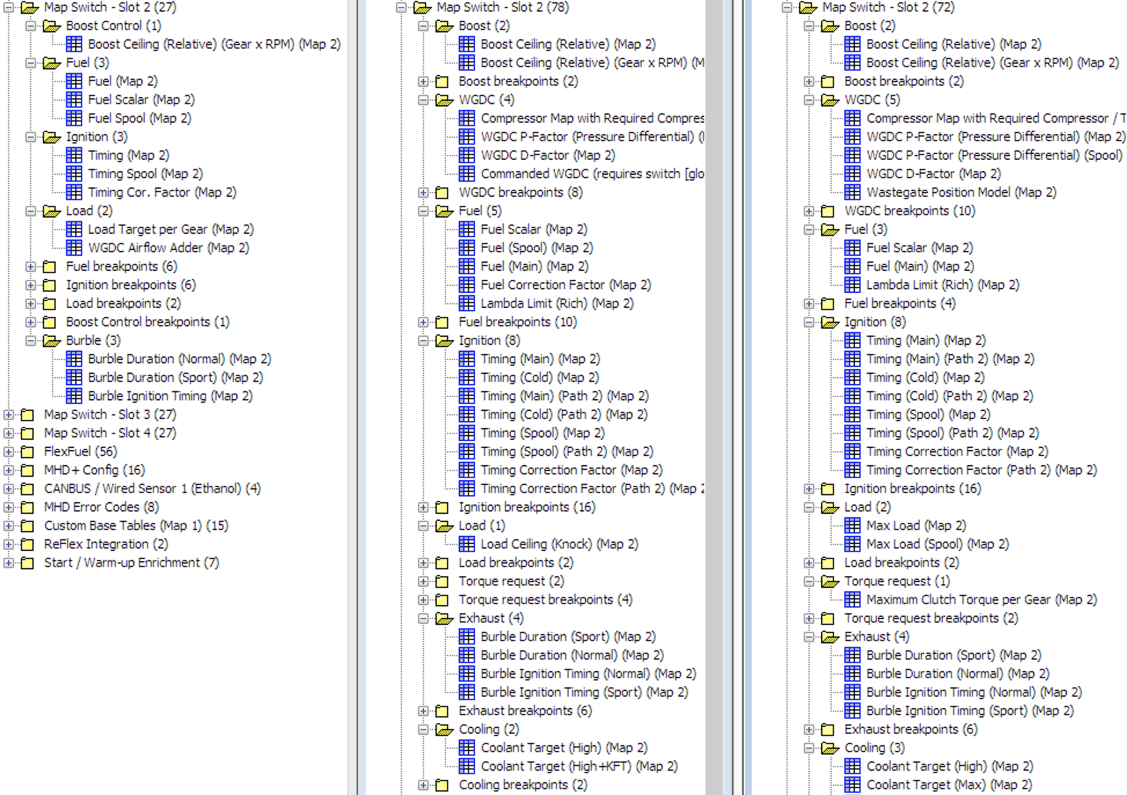
NOTE:
From left to right: MSD8x, MEVD, MG1

FlexFuel
For our FlexFuel implementation, we have created what we believe is the most flexible (hah!) setup available. Separate copies of all the above Map Switch tables are provided, along with a few additional tables. Blending / interpolation per table “grouping” is configurable per map slot, and the main blending functionality can be used with or without a CAN ECA installed (additionally DMTL wired ECA on N54). There are quite a few platform specifics regarding FlexFuel (*especially on N54, so please read!), so they will be detailed in their own subsection here vs. Platform Notes comments per section.

Enabling (with ECA)
In order to use FlexFuel with a CAN based ECA like our MHD Quick Install ECA, you first must have that ECA preset selected either in the app’s Flash Options, or in the Sensor Preset Selection table in the XDF. That gets the DME reading the Ethanol Percentage over CAN. You can monitor that reading with the Ethanol Content (CAN) parameter via our logging.
Now to enable FlexFuel blending, simply set the Enable FlexFuel table to 1 for the map slots where you want it to be active. This table can be found in the MHD+ Config folder. Below you can see a sample where FlexFuel is enabled for Map 1 and 2, but not for 3 or 4.
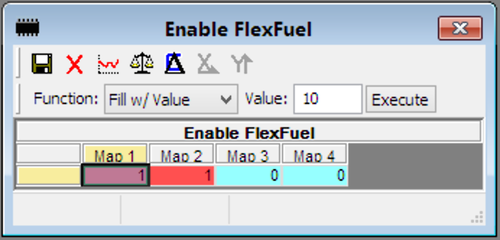
PLATFORM NOTES:
MSD8x DME: there is an additional ECA preset option, value 04 - Motiv FlexFuel ECA (DMTL Wired). If used, the Ethanol Sensor Conversion (DMTL Wired) table must be populated like on previous / legacy N54 FlexFuel tunes.

Enabling (without ECA)
The FlexFuel blending can easily be used if the vehicle does not have an ECA installed. This is done by setting a static ethanol content for a given map slot. Found in the MHD+ Config folder, there is one table per map slot, as seen here.
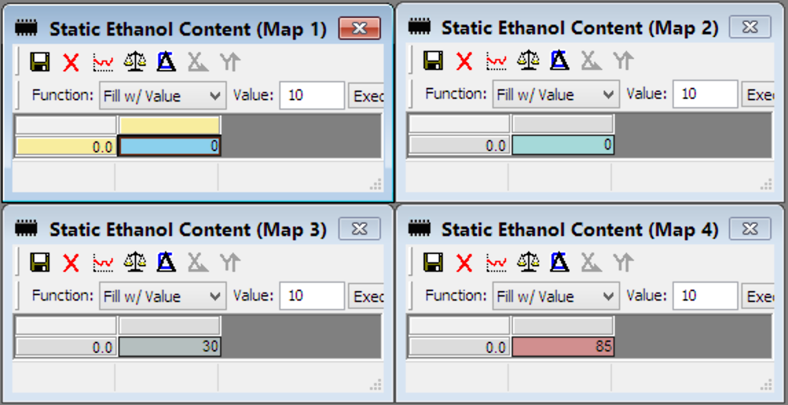
In this screenshot, only Map 3 and 4 would be using the FlexFuel blending, while feeding values of 30 and 85 to the interpolation tables (detailed in the next section). A value of 0 means the table is ignored.
IMPORTANT!
It is important to note that a value greater than 0 in these tables will override the ethanol percentage from the ECA for that map slot. The value coming from the ECA will still be loggable in the Ethanol Content (CAN) parameter (or Ethanol Content (Wired)) in case of Motiv DMTL Wired ECA), however an additional parameter Ethanol Content (Active) shows the actual percentage being fed to the interpolation tables. When the CAN value is not being overridden, Active will show the same exact value.
If you do not have an ECA installed and are just using the static values, Ethanol Content (CAN) will log as 0, while Ethanol Content (Active) will show the ethanol percentage as calibrated in your current map slot.

Blending / Interpolation
FlexFuel will automatically blend between two tunes based on a given ethanol content. When combined with an ethanol sensor in the fuel line, this takes all guesswork out of the equation. However, as stated above this blending logic can also be taken advantage of by those without a sensor and/or for a specific map the user wishes to always target a static ethanol percentage (ex. when using a consistent local pump, tune perfected for one specific blend, etc).

Table Groupings
How one table is blended against its FlexFuel variant is determined by the four categories of interpolation tables. Again, these interpolation tables are provided per map slot, so different map slots blend more or less aggressively, or not at all! The categories and the tables tied to them are as follows:
- Load Interpolation: Boost Ceiling (Relative), Boost Ceiling (Relative) (Gear x RPM), Compressor Map with Required Compressor / Turbine Power, WGDC P-Factor (Pressure Differential), WGDC D-Factor, Commanded WGDC, Load Ceiling (Knock), Maximum Clutch Torque per Gear
- Fuel Interpolation: Fuel (Scalar), Fuel (Spool), Fuel (Main), Fuel Correction Factor
- Fuel Scalar Interpolation: Fuel (Scalar), if applicable per platform
- Timing Interpolation: Timing (Main) (Path 1 / 2), Timing Cold (Path 1 / 2), Timing (Spool) (Path 1 / 2), Timing Correction Factor (Path 1 / 2)
- Knock Interpolation: Knock Factor (Cyl 1 - 6) on MEVD and MG1
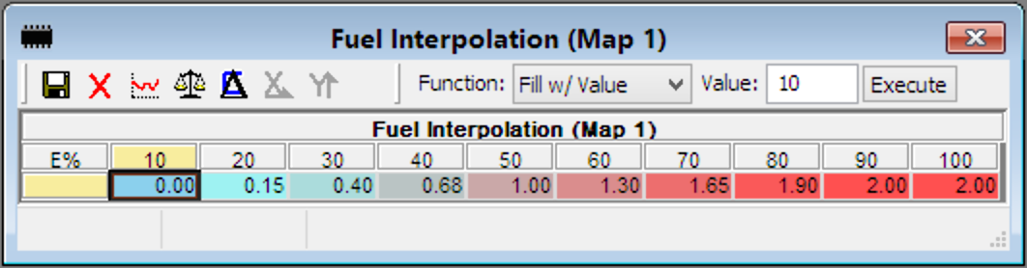
Above is a sample of the Fuel Interpolation table. As you can see, the value range is from 0.00 - 2.00. This is a very important distinction with our MHD+ implementation vs. a more basic 0.00 - 1.00 range in that it allows us to give you TWO sets of FlexFuel tables, detailed in the next section.

Main FF vs. FF2
If you open the updated XDF and expand the folders inside FlexFuel, you will see two of each table, the second of which contains (FF#2) at the end of the name. Those are considered the second set of FlexFuel tables.
The interpolation tables are factors used to blend between two tables. Which tables are used depends on what range the value is in. There are two possibilities:
- Factor values from 0.00 - 1.00 (Map Slot X → Main FF)
This is the traditional use case, where we are blending from the current map slot’s tables to the main FF tables. An interpolation factor of 0.00 would fully trace the map slot tables, while an interpolation factor of 1.00 would fully trace the main FF tables (and gradually in between, math shown in next section).

- Factor values from 1.00 - 2.00 (Main FF → FF#2)
This is our new use case, where we are blending from the main FF tables to the FF#2 tables. An interpolation factor of 1.00 would fully trace the main FF tables (same as above), while an interpolation factor of 2.00 would fully trace the FF#2 tables (and gradually in between, math shown in next section).
This is particularly useful if vehicle’s fuel system cannot support full E85, as you can setup the main FF tables for their max power ethanol blend, while using the FF#2 tables for E85. Sure, this can also be done by tapering back down the interpolation factors for the higher ethanol percentages (and you can do this if you wish), but providing the second set of tables gives much more precision and flexibility.

It is worth noting that you can have one table grouping (like Timing) blending from Map Slot → Main FF, while another grouping (like Fuel) is blending from Main FF → FF#2. Each interpolation grouping is separate from the others, as well as separate per map slot.

Show the Math!
For these examples, we will reference the fuel interpolation table pictured in the Table Groupings section. Let’s assume for the current rpm / load, the Fuel (Spool) table is targeting:
- Current Map Slot: 12.5 AFR
- FF: 13.0 AFR
- FF2: 14.67 AFR
If our Ethanol Content (Active) is 20%, we would have a blend factor of 0.15 from the fuel interpolation table. The math for the actual output from Fuel (Spool) would be:
((13.0 - 12.5) * 0.15) + 12.5 = 12.575 AFR
If our Ethanol Content (Active) is 45%, we would have a blend factor of 0.84 (the factor tables interpolate between cells as well). This gives the following Fuel (Spool) output:
((13.0 - 12.5) * 0.84) + 12.5 = 12.92 AFR
Finally, if our Ethanol Content (Active) is 80%, we would have a blend factor of 1.90. This puts us in the second range, where we blend from FF to FF2. We first subtract 1 from the blend factor before using it in the equation. Here we get the following Fuel (Spool) output:
((14.67 - 13.0) * 0.90) + 13.0 = 14.5 AFR
As you can see, there are two equations based on the interpolation factor itself. They work properly for all table types (signed, unsigned, one byte, two byte, etc).
Factors 0.00 - 1.00: ((FF - Map Slot) * Factor) + Map Slot
Factors 1.01 - 2.00: ((FF2 - FF) * (Factor - 1)) + FF

Enable Individual FF#2 Blending
This toggle table is provided for those who wish to implement something like two different FlexFuel aggressiveness levels for one map slot vs. another, or for one map slot to be FlexFuel and another be FlexFuel + Meth, etc.
Setting this table to 1 will blend from map slot to FF#2 for ipol factors greater than 1.0. Any other value keeps the default functionality (as detailed in above previous sections) where ipol factors greater than 1.0 blend from FF to FF#2.
Below are two simplified examples to demonstrate the effect of this toggle. For more details on FF blending, please review the previous sections Main FF vs. FF2 and Show the Math!

Example with toggle set to 0:
- Interpolation factors 0 - 1.0 blend from map slot to FF1
- Interpolation factors 1.01 - 2 blend from FF1 to FF2

Example with toggle set to 1:
- Interpolation factors 0 - 1.0 blend from map slot to FF1
- Interpolation factors 1.01 - 2 blend from map slot to FF2

Fuel Start and Warmup Enrichment
As mentioned earlier, we decided not to include the fuel start, restart, and warmup tables per map slot. This was done in order to simplify the tuning process for these aspects of fueling. Instead, we have provided a single table (in the FlexFuel > Fuel folder): Start and Warmup Enrichment (Ethanol Compensation). Its output is a multiplication factor that gets applied to the appropriate variables behind the scenes to provide enrichment compensation for ethanol during start up and warm up.
To use this table, simply enable FlexFuel or set a static ethanol content for a given map slot. It functions the same as the Fuel Scalar table, offering a factor range of up to 2.00. You should likely only use values > 1.0 where appropriate, while using 1.0 for the regions you do not wish to add any additional fuel compensation. Additionally, you can now leave the base tables (global) for these aspects 100% stock.
- X-axis: Ethanol Content (Active)
- Y-axis: Engine Temp (°C)
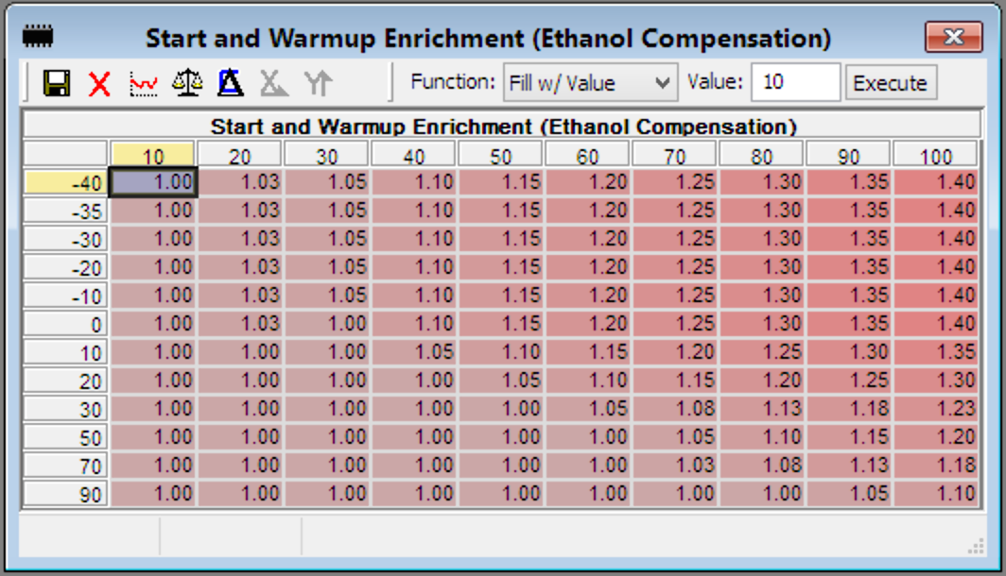
NOTES:
- Factor values < 1.0 can be used to reduce fueling during start / warmup.
- This table is always used when FF or static E is set for a map slot.
- This table is not affected by the Fuel Interpolation tables per map slot.

N54 Specific FlexFuel Details
Since N54 FlexFuel has existed in a basic form for some years now, it had to be handled a little differently to maintain backward compatibility with those previous tunes. Additionally, MSD8x is restricted by its available CAL space, so that places limits on what we can offer. The key differences are as follows:
- N54 only has one set of FlexFuel tables available. Unfortunately there is not enough CAL space to provide the FF vs. FF#2 implementation available on MEVD and MG1. Also related to this, the N54 FF interpolation tables go from 0 to 100%, with 0 fully tracing the current map slot, and 100% fully tracing the FF table. For intermediate math, please see the Show the Math! section above.
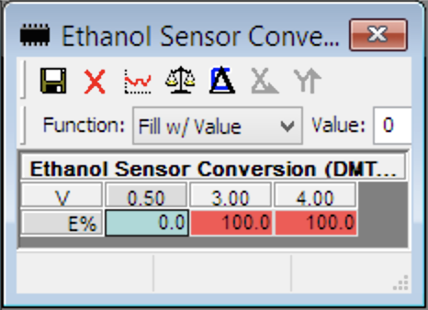
- N54 now supports both CANBUS based ECA as well as the traditional Motiv FlexFuel ECA which was wired into the DMTL pin. Those of you with a Motiv ReFlex are encouraged to utilize the CANBUS integration for sending E% to the DME, as you gain the benefit of the two-way integration with PI failsafe / limp, logging of ReFlex data right in MHD, CANBUS WGDC control, etc. If still using the DMTL wired method, that table should be filled as shown to the right.
- Separate FF Knock tables are not provided due to CAL space constraints. If there end up being many use cases where this would be necessary (along w/ Knock Interpolation blending tables), let us know and we can evaluate the feasibility of adding them.
- Fuel Start and Warmup compensation are still separated off from the main FF tables (to allow utilization of these tables for a Static E% map slot), but instead of one new 3D table, there is a copy of both Fuel (Start) and Warm-up Enrichment Factor. These tables are used along with the separate Start and Warm-up Enrichment Interpolation which determines how to blend between the main Fuel (Start) and Warm-up Enrichment Factor tables and their E85 table copies for a given E%. Remember, that E% can come from a CANBUS ECA kit, the Motiv DMTL wired kit, or a Static E% table for a given map slot (for a hard-coded E% map).

Specific Use Cases
- I have a map already perfected for a certain ethanol percentage and don’t want that one specifically to have to blend (want to trace the tune’s tables exactly).
  - Copy that map’s table data to whichever map slot you want it to be. Set the static E content for that map to the appropriate blend, while making sure to tune the new Fuel Start and Warmup Enrichment table. Set all interpolation factors for that map slot to 0.00.
- I only want to take advantage of the new 3D Boost Ceiling table, nothing else.
  - Set the enable toggle to 1, and tune the base copy in Custom Base Tables accordingly. Disable mapswitch and FF, and set all static E contents to 0.
- I only want to take advantage of the simplified Fuel Start / Warmup Compensation, nothing else.
  - Without ECA: Set the static E content for map 1 to the appropriate blend, while disabling mapswitch and FF.
  - With ECA: Enable FF for map 1, set static E content to 0, and set all interpolation factors to 0.00.
- I want to use FlexFuel but I'm limited by my fuel system.
  - Enable FF for the appropriate map slot(s). Tune the FF tables for the max power ethanol the fuel system can support, and tune the FF#2 tables for full ethanol. Use blend factors 0.00 - 1.00 for E0 - Max Power E, and then 1.01 - 2.00 for Max Power E - Full E.
  - Alternatively: Enable FF for the appropriate map slot(s). Tune the FF tables for the max power ethanol the fuel system can support, while padding Fuel Scalar to support full E. Use blend factors 0.00 - 1.00, but taper them back down at least for Load Interpolation to limit power / stay within the limitations.
- I only want to use Map Switch.
  - Enable mapswitch, set the active map slots to a of value 1-4 (and tune each slot appropriately), make sure the Enable FlexFuel table is set to all 0, and each static E content is set to 0. You can now ignore all the FF and FF#2 tables.

KnockCEL
KnockCEL is another “unique to MHD” feature in the BMW world that is quite useful in alerting a driver to issues with their fuel (or tune!) without the need to constantly have the logger open. It will flash the CEL (check engine light) if either a configurable single cylinder knock count is exceeded, or a configurable total cylinder knock count is exceeded. There are a few differences in which ancillary tables are provided per platform, see platform notes below:
PLATFORM NOTES:
- MSD8x DME: not yet released, but will match MG1 DME tables
- MEVD DME: no separate enable toggle or minimum load threshold
- MG1 DME: contains all 5 tables shown below

Main Tables
- Enable KnockCEL: overall toggle to enable or disable the feature
- Load Threshold (Minimum): minimum load that must be exceeded in order for knockCEL to be active
- Pedal Threshold (Minimum): minimum accel pedal that must be exceeded in order for knockCEL to be active
- Single Cyl Total: if any individual cylinder’s timing correction exceeds this value (assuming the knockCEL enable conditions are met), the CEL will blink rapidly
- Sum Total: if the total timing corrections for all cylinders exceeds this value (assuming the knockCEL enable conditions are met), the CEL will blink rapidly.
NOTES:
- For MEVD DME without the separate Enable toggle and Load Threshold, knockCEL is enabled simply when the accel pedal threshold is exceeded
- The Single Cyl / Sum Total tables are intentionally positive values. They are compared to the absolute value of the cylinder timing corrections as logged w/ MHD.

ReFlex Integration
There are two different levels of integration with the Motiv ReFlex depending on your DME / platform. The initial basic version is shared on MSD8x, MEVD, and MG1 PPC (gen1 B58) DME. With our gen2 release for MG1 Aurix DME, we are introducing our advanced integration. The other earlier DME / platforms will be updated to this advanced level in the future as time allows. So you tuners can plan, this back-porting will likely go in reverse order, with MG1 PPC (gen1 B58) getting it added first, as that is most similar to the code we wrote for gen2.
PLATFORM NOTES:
- MSD8x DME: basic integration only
- MEVD DME: basic integration only
- MG1 PPC DME: basic integration only
- MG1 Aurix DME: advanced integration only

Basic Integration
Our basic ReFlex integration allows for logging of the relevant information the device sends on PT-CAN, includes failsafes (and configurable limp modes) for PI errors and low pressure fuel pressure being too low, as well as broadcasting of WGDC onto PT-CAN so that the DME can control a conventional 3-port or 4-port boost solenoid via the ReFlex. This allows for native boost per gear, per map slot, and per FlexFuel slot, giving you unmatched flexibility and control. Basic integration requires all PI calibration, and Aux 2/3/4 calibration to be done on the ReFlex directly. Aux1 can be set on the ReFlex to instead use the WGDC we transmit over CAN.

Enabling
To enable the basic integration, all you need to do is set the Sensor Preset Selection table to the correct value for the ReFlex (typically 02). Additionally, some gen1 B58 G-Series vehicles have a conflict with the CAN ID we used, so you will need to set the Use Alternate CAN ID for Message Reception table to 01. This is only required on those specific vehicles, and you must configure your ReFlex firmware to match.

Logging Parameters
The following are the parameters that the ReFlex sends to the DME on PT-CAN. Whether they contain valid data or not depends on the hardware you have connected to the ReFlex (such as ethanol content analyzer or low pressure fuel sensor).
- Ethanol Content (CAN): ethanol percentage, requires ethanol content analyzer to be wired to the ReFlex.
- ReFlex PI DC (Base): base injector duty cycle from the gasoline ReFlex table
- ReFlex PI Scaling Factor: blending factor used to interpolate between the gasoline and ethanol IDC tables on the ReFlex
- ReFlex PI DC (Final): final injector duty cycle after interpolation with the ethanol ReFlex IDC table, using the scaling factor above
- ReFlex PI Error: bitwise mask of different errors on the ReFlex
- ReFlex Aux Pressure: pressure reading from the aux sensor input on the ReFlex (if connected), typically used for low pressure fuel pressure on cars that don’t have one in OEM form
- ReFlex Aux Output 1 DC: duty cycle the ReFlex is currently outputting to aux 1 output, typically WGDC
- ReFlex Aux Output 2 DC: duty cycle the ReFlex is current outputting to aux 2 output, typically second low pressure pump trigger

Safeties
The vehicle will be in limp mode along with a custom MHD+ DTC error code seen in Read Codes as well as a CEL (check engine light), for the following scenarios:
- MHD001: CAN timeout. Check all CAN wires connections with the ReFlex
- MHD005: ECA signal error (or water contamination), check that ECA is wired to the ReFlex correctly. If you do not have an ECA hooked up, set table ReFlex FlexFuel Sensor Absent to 1 to prevent it
- MHD006: Aux pressure fell below the warning threshold set in table ReFlex Aux Pressure Sensor Safety. If you do not have a sensor hooked up or do not want a limp mode for this, set the table to 0.
- MHD007: PI injector error, check all wiring to your PI injectors from the ReFlex.

Advanced Integration
Our advanced ReFlex integration was designed to give full control over the ReFlex, including PI and all of its auxiliary outputs. This means you only need to flash the ReFlex firmware one time to the latest MHD+ supporting firmware, and from there you can make all the tuning changes you’d ever need right in the DME. The minimum ReFlex firmware required is v6.24, so please ensure your ReFlex is properly updated or else the advanced integration will not work.

Enabling
Similar to basic integration, first you will need to set the Sensor Preset Selection table to the correct value for the ReFlex (typically 02). That table by itself will enable logging the incoming ReFlex data (like E%, aux pressure, aux duty cycles, PI IPW, etc). If you don’t make any other changes, the ReFlex will continue to operate in “standalone mode,” and you will need to reflash the ReFlex to make changes to its PI IDC, Aux DC, etc. But “I don’t want to have to reflash the ReFlex anymore!” you say, and that’s where the new “remote control” config bytes come in.
Our advanced integration allows you to selectively control any of the ReFlex’s outputs via individual toggles. If a toggle is left set to 0, the ReFlex will remain in control of that item via its own internal tables and will not use the values being sent from the DME. The toggles include:
- Enable DME Control of ReFlex WGDC: when enabled, we send the final WGDC% from the DME over CAN to the ReFlex, which will output it to the solenoid. Make sure your boost solenoid is hooked up to Aux 1 on the ReFlex. This allows for boost per gear, per map slot, as well as being blendable to both FlexFuel tune slots.
- Enable DME Control of ReFlex Aux 2/3/4 Output: when enabled, we send the final DC% output from our custom Aux 2/3/4 Output duty cycle tables to the ReFlex for that respective Aux output. More details can be found in the Aux Outputs section below.
- Enable DME Control of ReFlex Port Injection: this is the real showcase of our advanced integration, and has a few valid values:
  - 00: Disabled (Calibrate PI directly on the ReFlex)
  - 01: Manual (see details in section below)
  - 02: Auto (see details in section below)
  - 99: Calculation Output (see details in section below)

Enabling - Gen1 B58 Specific
Since Gen1 B58 MHD+ was originally released with Basic ReFlex Integration, one extra step is now required to enable / switch over to the Advanced Integration as released with Gen2 B58 / S58. To make this change, please set the following table:
- Enable Advanced ReFlex Integration and Control: 01
Any other value, and the DME will continue using the Basic ReFlex integration. You will also need to ensure your ReFlex firmware is updated to v7.00. Lastly, please note that the logging parameters related to Basic Integration now have Legacy added to their name to distinguish them.

Tuning with Automatic Port Injection
Automatic Port Injection mode is designed to be as close as possible to how an OEM ECU controls dual injection (DI + PI). First and foremost, it requires port injectors with proper and precise calibration data. If your injectors do not have this required information available (detailed below), then you should instead use the Manual Port Injection mode.
The Injector Dynamics ID1050x, 1300x, and 1700x are all examples of port injectors with proper calibration data available. We’ve utilized their GTR style table characteristics for our port injector implementation. The calibration sheets referenced later in this guide can be found here. The DME tables we’ve added match the table names on those spreadsheets to make populating them easier.

IMPORTANT NOTE:
Traditionally when tuning PI (until now), you would have to reduce fueling on the DME side to avoid injector limits by lowering the Fuel Scalar table(s) in the areas where PI is spraying and supplementing the total fuel. This is no longer needed. In fact, you actively must not do this when using Automatic PI. The OEM / Mapswitch / FlexFuel Fuel Scalar tables should be set as if the vehicle is running DI only, using as high of a scalar value as required for the total fuel mass to be delivered.

Automatic PI Tables
The following tables must be calibrated when utilizing our Automatic PI strategy. In the XDF, they can easily be identified as the required tables are suffixed with (Auto) and (General). The General tables are required whether you are using Auto or Manual PI. The data shown in the tables in our descriptions below are sample data for IDX 1050 injectors on a gen2 B58 running an upgraded turbo.

Low Pressure Fuel Sensor Source
A valid low pressure reading is crucial to properly operating port injectors, as their flow is dependent on differential pressure (fuel pressure - boost pressure). We provide three possible settings for this table:
- 00: Static Substitute Value (boost referenced FPR required! otherwise engine damage can occur). The value in the Base Fuel Pressure (Low Pressure) table is used.
- 01: OEM Sensor Value (only on vehicles with OEM LPFP sensor!)
- 02: Motiv ReFlex Aux Pressure
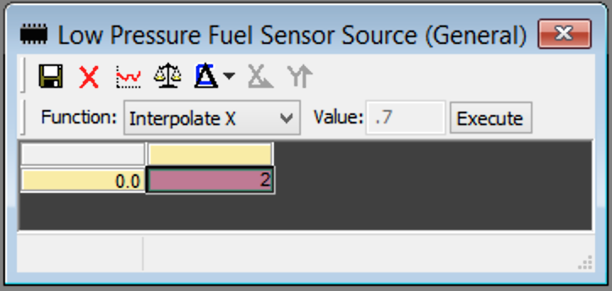
IMPORTANT NOTES:
- Even with a boost referenced FPR, using a pressure substitute value is not optimal. A physical low pressure sensor is always recommended.
- A boost referenced FPR is also highly recommended in addition to a physical low pressure sensor if you plan to run boost levels in excess of 32-34 psi. Without one at higher boost levels, differential pressure can end up too low and max out the error compensation.

Base Fuel Pressure (Low Pressure)
This is the normal operating pressure of your vehicle’s low pressure fuel system. This must be entered into both this table and into the IDX injector calibration sheet at the very top (in the “Enter Base Fuel Pressure (psid)” field. Gen1 and Gen2 B58 typically run on average ~5.7 bar (82.7 psi), whereas older F-series vehicles are ~5 bar (72 psi). If you are unsure of this value, you should first log it at idle/cruise/WOT with MHD. If using option 0 for LPFP sensor source (above), this value will also be used as the static substitute value for low pressure sensor.
IMPORTANT NOTE:
Accuracy of this value is very important, as it directly affects the calculated Injector Scalar on the IDX calibration sheets. If you change the base pressure, make sure to re-input it into the IDX sheet and get the updated Injector Scalar as well!

Injector Scalar
This is the flow rate of your port injectors, in cc/min. This must be entered appropriately for your Base Fuel Pressure (Low Pressure) above. Below is a sample of these from the IDX 1050 sheet and then set to match in our XDF tables.
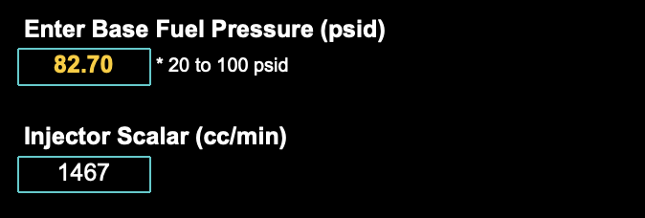
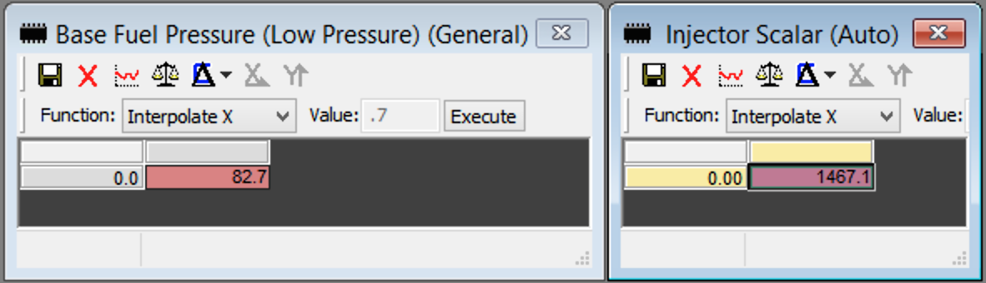

3D Injector Latency
This table provides the injector deadtime (or latency) compensation for a given battery voltage and differential fuel pressure. This table’s data and axis values can be copied directly from the IDX spreadsheet matching your injectors. The output of this table is additively applied to the effective IPW.
- X-axis: Battery voltage
- Y-axis: Differential fuel pressure
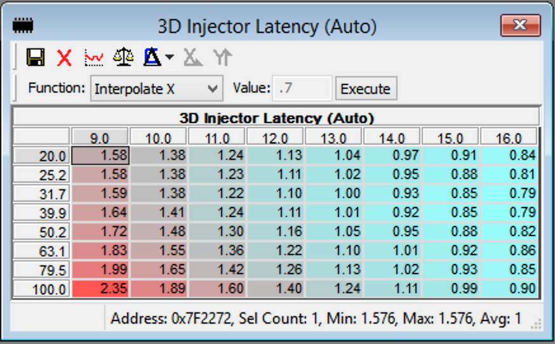

Differential Fuel Pressure Compensation
This table provides a correction factor based on the current differential fuel pressure error. The error is the percent difference between the current differential pressure and calibrated base pressure. This table’s data and axis values can be copied directly from the IDX spreadsheet matching your injectors. The output of this table is multiplicatively applied to the effective IPW.
- X-axis: Differential fuel pressure error
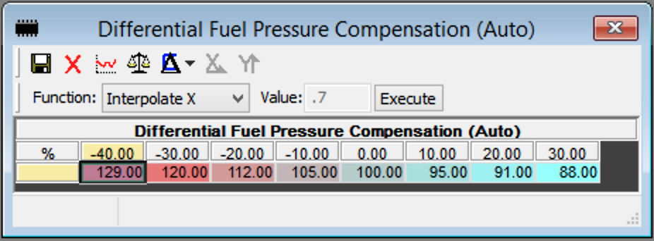

Non-Linear Injector Compensation
This table provides a correction factor for the inherent nonlinearity of injectors in small pulse widths. This factor is applied only while effective IPW is less than the maximum value in the single cell Non-Linear Injector Compensation Maximum IPW table. Both of these tables’ data and axis values can be copied directly from the IDX spreadsheet matching your injectors. The output of this table is multiplicatively applied to the effective IPW.
The benefit of providing this table (and not simply allowing only IPW above this) is that you can start PI earlier with quite small IPW and slowly ramp it in. The smoother the better.
- X-axis: Effective injector pulse width
- Y-axis: Differential fuel pressure
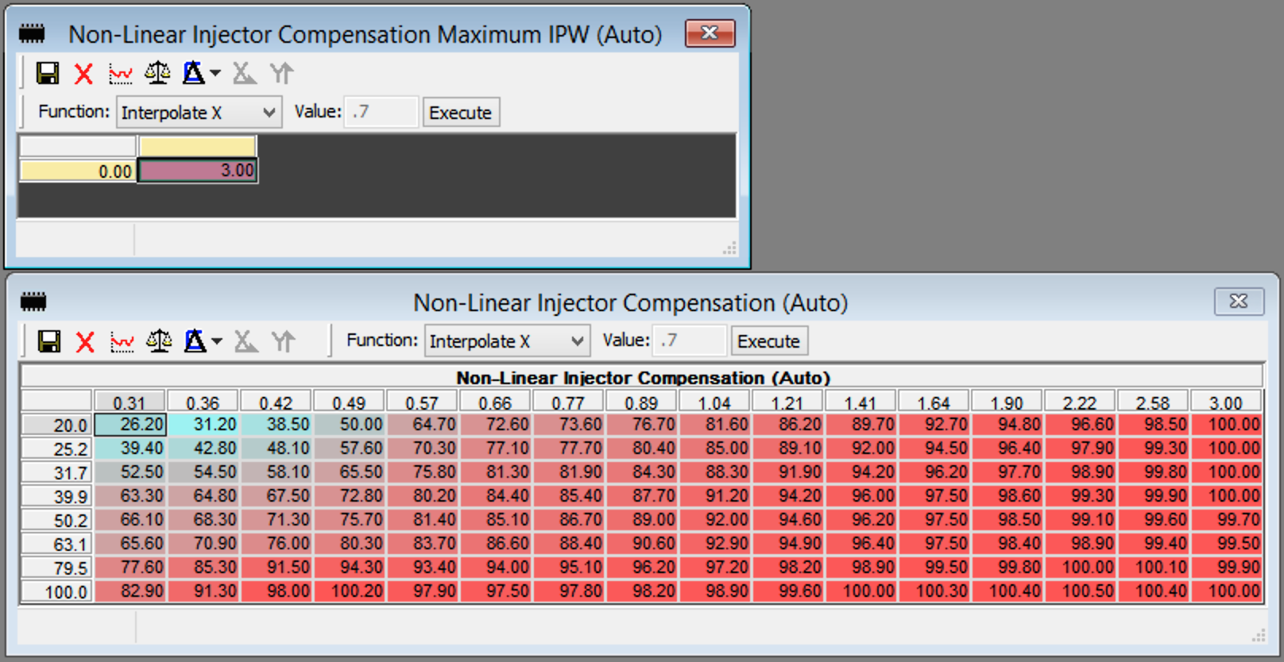

PI / DI Percent Split (Gasoline / Ethanol)
These tables are the main drivers for how much of the total fuel mass is injected by the PI system. If FlexFuel (or static E%) is being used for the current map slot, they are blended between by the Port Injection Interpolation table. The tables are intentionally capped at a maximum of 85% to ensure that the DI system can function appropriately. The samples shown are done as an example of slowly and smoothly ramping in PI.
- X-axis: RPM
- Y-axis: Load

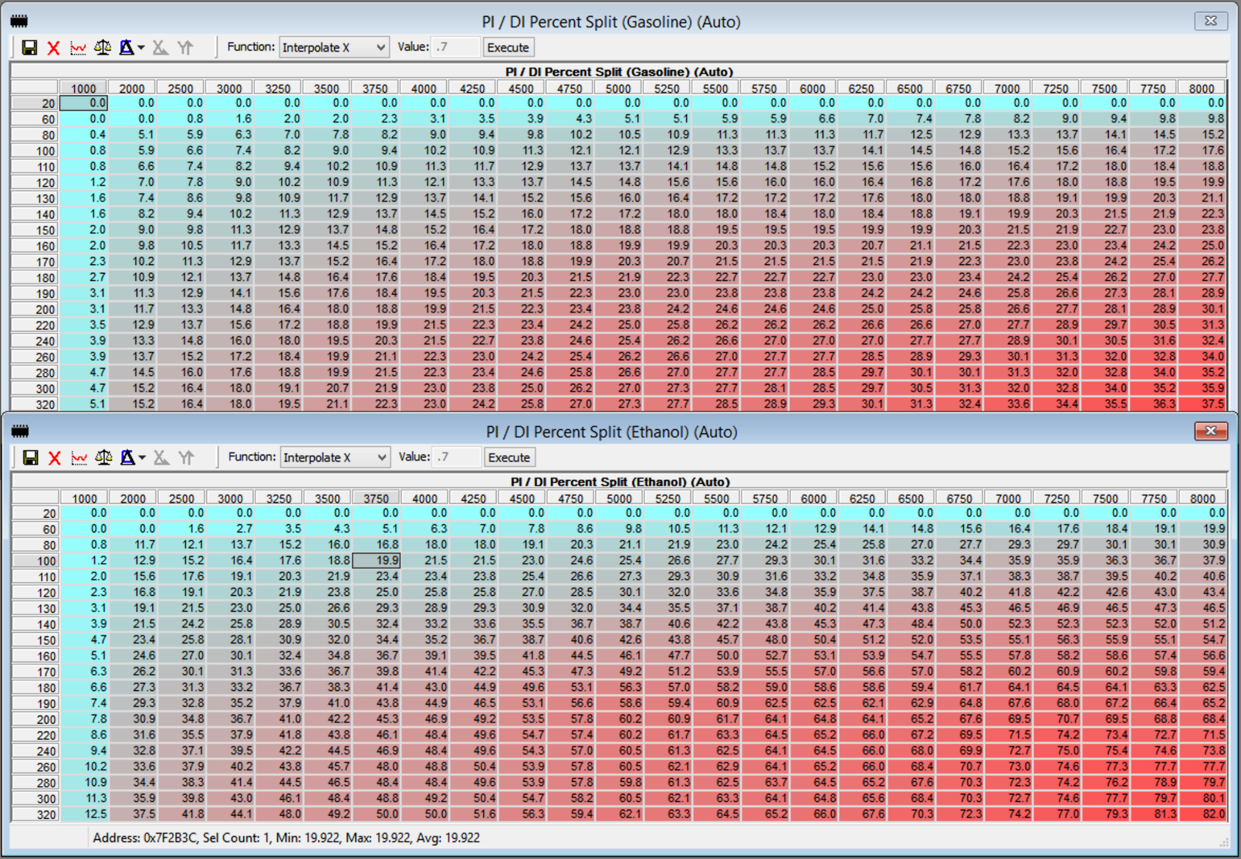

Maximum Allowed DI Usage
This table acts as a built-in safety to keep the resulting DI share of the fuel mass away from limits like injection window, HPFP MSV angle maxing, etc. If the DI fuel mass (mg/stk) (after the percent split from above is applied) is greater than the maximum fuel mass looked up from this table, our Automatic PI strategy will automatically apply this extra fuel mass to the PI share. This can be seen in the logging parameter PI+ Port Inj Split Adder. While the maximum total split percent in the tables above is capped at 85% for the PI share, the adder from this table allows bringing that up to a maximum of 95%. This would be seen as a logged value of 85% in Port Inj Split Req, a 10% value in Port Inj Split Adder, and a 95% value in Port Inj Split Final.
It is best practice to try and set the PI / DI split tables more accurately and utilize this solely as a safety net. You can use the logged output of the Port Inj Split Adder table to determine where you need to add more split request in those tables.
The values shown below are conservative. You can log MSV after PI, DI IDC, Ethanol Content, and PI+ Fuel Mass (DI Share) during WOT to determine how much more you are able to raise these values. That said, they should not be set to the absolute edge; leave some safety room. If you have upgraded DI injectors / HPFP, you will also want to raise the values in this table. Again that should be done via logging of those above four parameters.
- X-axis: RPM
- Y-axis: Ethanol content (active)
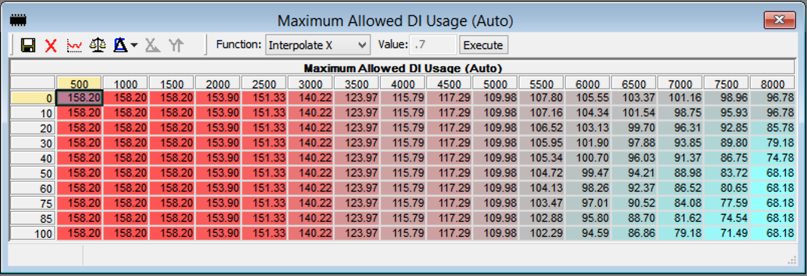

Port Injection Interpolation
This table is used to blend between the two PI / DI Percent Split tables when using Automatic PI, or between the two PI Injector Pulse Width tables when using Manual PI. Since there is only one ethanol table for each, the interpolation factor range is only from 0.00 to 1.00
- X-axis: Ethanol content (active)
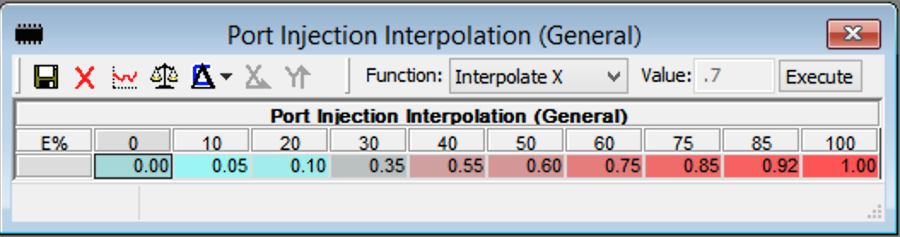

Minimum Injector Pulsewidth
This table is the minimum effective injector pulse width (IPW). If the calculated effective IPW is below the value in this table, the port injectors will not be sent any IPW and they will be inactive. This table’s value can be copied directly from the IDX spreadsheet matching your injectors.

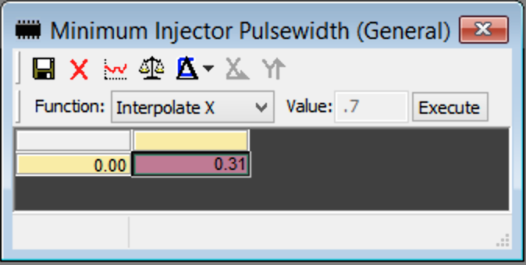

Calculation Output Mode
Calculation output mode is a special mode of Automatic Port Injection which is designed for logging / validation only. All of the Automatic calculations described above will still run and be loggable, except for the fact that the final PI IPW is not sent on CAN to the ReFlex, and the DME’s DI fuel mass is not reduced / touched. This is useful for tuners to get an idea of how the system works, validating their injector calibration and fuel mass limits, etc.

Tuning with Manual Port Injection
Manual Port Injection mode is basically a copy of the PI tables that the ReFlex has in its own calibration, but moved to the DME so that they can be tuned and updated there as part of the normal DME tuning process. This mode should only be chosen if you are unable to find accurate calibration data for your port injectors, as Automatic PI is far superior.
When using Manual PI mode, you will be required to reduce the DI fuel mass yourself via the Fuel Scalar table(s). This is because it cannot be adjusted automatically without that port injector calibration and characterization data.

General Tables
The following four General tables detailed in the Automatic PI section must also be set for Manual PI. You can read about each of them in their respective sections above.
- Low Pressure Fuel Sensor Source, Base Fuel Pressure (Low Pressure), Port Injection Interpolation, Minimum Injector Pulsewidth

Manual Tables
These tables are a copy of the three tables used to tune PI on the ReFlex itself.
- PI Injector Pulse Width (Gasoline): The actual IPW you desire for the port injectors
  - X-axis: RPM
  - Y-axis: Load
- PI Injector Pulse Width (Ethanol): Same as above, but for ethanol. This table is blended / interpolated with the Gasoline table via the factor from the Port Injection Interpolation table in the General section.
- Low Pressure Fuel Pressure Factor: multiplicative factor applied to the resulting actual IPW (after blending between gasoline / ethanol IPW tables)
  - X-axis: Low pressure fuel pressure

Aux Outputs
DME remote control of the ReFlex Aux 2 / 3 / 4 outputs are all configured the same way and have the same table set available. For each aux output, if you wish to activate the use of these tables, you will first need to set Enable DME Control of ReFlex Aux # Output to 01. Aux 1 is always dedicated to WGDC output as explained in a previous section Tuning tables provided per Aux 2 / 3 / 4 are as follows:
- ReFlex Aux # Pedal Threshold (Minimum w/ hysteresis): The ON cell is the minimum pedal required to activate this aux output. The OFF cell is what pedal must fall below then to deactivate this aux output. This is done in order to avoid small fluctuations in quickly triggering on/off the aux. It is particularly useful when activating Nitrous or extra fuel pumps.
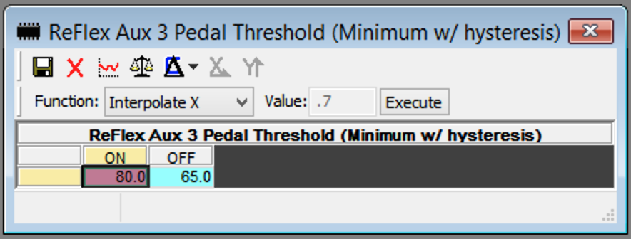
- ReFlex Aux # Set as Relay Trigger: Set to 1 if this aux output is triggering a relay. It will then only output DC% of either 0 or 100% (0-49.9% treated as 0%, 50-100% treated as 100%)
- ReFlex Aux # Duty Cycle: A 3D duty cycle table is provided per aux output, per map slot, and for both FlexFuel slots. It can be interpolated by E% like other mapswitch tables.
  - X-axis: RPM
  - Y-axis: Boost (relative)
- ReFlex Aux # Output Interpolation: A separate interpolation table is provided per aux output and per map slot. These function the same as all of the other FlexFuel interpolation tables, in that the interpolation factor range can go from 0.00 to 2.00. It can also do the selective blending dictated per the Enable Individual FF#2 Blending toggle, which is explained in detail in the FlexFuel section.
  - X-axis: Ethanol content (active)

Logging Parameters
- Ethanol Content (CAN): ethanol percentage, requires ethanol content analyzer to be wired to the ReFlex.
- ReFlex Error Bits (CAN): bitwise mask of different errors on the ReFlex. Specific error details can be seen in MHD on the Read Codes screen.
- ReFlex Aux Pressure (CAN): pressure reading from the aux sensor input on the ReFlex (if connected), typically used for low pressure fuel pressure on cars that don’t have one in OEM form.
- ReFlex Aux 1 DC (CAN): duty cycle the ReFlex is currently sending to aux 1 output, typically WGDC. This is sent back from the ReFlex to the DME to monitor / verify that the MHD calculated value is being output.
- ReFlex Aux 2 DC (CAN): duty cycle the ReFlex is currently sending to aux 2 output, typically a second low pressure pump trigger. This is sent back from the ReFlex to the DME to monitor / verify that the MHD calculated value is being output.
- ReFlex Aux 3 DC (CAN): duty cycle the ReFlex is currently sending to aux 3 output. This is sent back from the ReFlex to the DME to monitor / verify that the MHD calculated value is being output.
- ReFlex Aux 4 DC (CAN): duty cycle the ReFlex is currently sending to aux 4 output. This is sent back from the ReFlex to the DME to monitor / verify that the MHD calculated value is being output.
- ReFlex PI IPW (CAN): final IPW the ReFlex is sending to the port injectors. This is sent back from the ReFlex to the DME to monitor / verify that the MHD calculated value is being output.
- ReFlex Batt V (CAN): battery voltage at the ReFlex via onboard ADC.
- ReFlex Aux 2 Interpolation: current interpolation factor used for blending aux 2 duty cycle tables.
- ReFlex Aux 3 Interpolation: current interpolation factor used for blending aux 3 duty cycle tables.
- ReFlex Aux 4 Interpolation: current interpolation factor used for blending aux 4 duty cycle tables.
- ReFlex Aux 1 DC (MHD Output): calculated aux 1 duty cycle to be sent on CAN to the ReFlex. This will be the same as the final WGDC %.
- ReFlex Aux 2 DC (MHD Output): calculated aux 2 duty cycle to be sent on CAN to the ReFlex.
- ReFlex Aux 3 DC (MHD Output): calculated aux 3 duty cycle to be sent on CAN to the ReFlex.
- ReFlex Aux 4 DC (MHD Output): calculated aux 4 duty cycle to be sent on CAN to the ReFlex.
- PI+ Fuel Mass (Total): total fuel mass in mg/stk that is currently required to be supplied.
- PI+ Fuel Mass (PI Share): fuel mass in mg/stk that will be supplied via the supplemental port injectors.
- PI+ Fuel Mass (DI Share): fuel mass in mg/stk that will be supplied via the direct injection system.
- PI+ LPFP Setpoint: target fuel pressure, aka the value in Base Fuel Pressure (Low Pressure) table. Used in forming Diff. Fuel Press Error.
- PI+ LPFP Actual: current low pressure fuel pressure reading, taken from either the ReFlex aux pressure sensor or OEM low pressure sensor depending on table config.
- PI+ Diff. Fuel Press: differential fuel pressure, formed via LPFP Actual - Boost
- PI+ Diff. Fuel Press Error: differential fuel pressure error, which is the error percentage between Diff. Fuel Press and LPFP Setpoint.
- PI+ Diff. Fuel Press Corr Fac: correction factor being applied from the Differential Fuel Pressure Compensation table lookup.
- PI+ Non-Linear Corr Fac: correction factor being applied from the Non-Linear Injector Compensation table lookup.
- PI+ Latency Corr: injector latency / deadtime correction being applied from the 3D Injector Latency table lookup.
- PI+ Port Inj Interpolation: current interpolation blending factor used between PI Gasoline and Ethanol tables, if the current map slot has FlexFuel active or is utilizing a static E%.
- PI+ Port Inj Split Req: the desired fuel mass percentage to be supplied by the port injection system, from the PI / DI Percent Split (Gasoline / Ethanol) tables after interpolation.
- PI+ Port Inj Split Adder: the additional percentage of fuel that is to be supplied by the port injection system for fuel masses that end up greater than the mg/stk from the Maximum Allowed DI Usage table lookup.
- PI+ Port Inj Split Final: Port Inj Split Req + Port Inj Split Adder
- PI+ Direct Inj Split Final: 100% - Port Inj Split Final
- PI+ Port Inj Status: status byte showing if the PI+ system is operating as expected
- PI+ Port Inj Effective IPW: injector pulse width calculated from the desired fuel mass in mg/stk to be supplied by the port injection system, calculated from the Injector Scalar.
- PI+ Port Inj Actual IPW: final injector pulse width to be delivered, which is effective IPW after all corrections. This is sent to the ReFlex on CAN.
- PI+ Port Inj IDC: injector duty cycle of the PI system for the current IPW and injection window.
- PI+ Direct Inj IDC: injector duty cycle of the DI system for the current IPW and injection window.

Safeties
The vehicle will be in limp mode along with a custom MHD+ DTC error code seen in Read Codes as well as a CEL (check engine light), for the following scenarios:
- MHD001: CAN timeout. Check all CAN wires connections with the ReFlex
- MHD002: CAN timeout. Check all CAN wires connections with the ReFlex
- MHD005: ECA signal error (or water contamination), check that ECA is wired to the ReFlex correctly. If you do not have an ECA hooked up, set table ReFlex FlexFuel Sensor Absent to 1 to prevent it
- MHD006: Aux pressure fell below the warning threshold set in table ReFlex Aux Pressure Sensor Safety. If you do not have a sensor hooked up or do not want a limp mode for this, set the table to 0.
- MHD007: PI injector error, check all wiring to your PI injectors from the ReFlex.
- MHD008: ReFlex Cam sync error, check harness and wiring..
- MHD009: ReFlex Crank sync error, check harness and wiring.
- MHD010: ReFlex Firmware is older than required by the current MHD+ code, please update the firmware.
- MHD011: ReFlex CAN Data Corrupt, ensure latest firmware and app version.
- MHD012: ReFlex aux pressure sensor error, check harness and wiring.
- MHD013: ReFlex not receiving CAN data, check harness and wiring.
- MHD014: Max allowed PI Split % (95% total) exceeded.
- MHD015: Custom Safety Condition Triggered

New / Custom Tables

Boost Ceiling (Relative) (Gear x RPM)
This new table is for those who wish to be able to set a more exact boost curve per gear. This table technically functions as a ceiling, so lower throttle inputs will still function properly as-is. This table is provided per map slot, as well as FF and FF#2 copies. As this table does not exist in the stock DME, the “base” or map slot 1 copy of this table is found in the new Custom Base Tables folder.
To enable it, in MHD+ Config set Enable Custom 3D Boost Ceiling Table to 1. Once enabled, it becomes active in all utilized map slots as well as FF and FF#2 if they are being utilized.
- X-axis: Gear
- Y-axis: RPM
- Z-data: Boost (psi, relative)
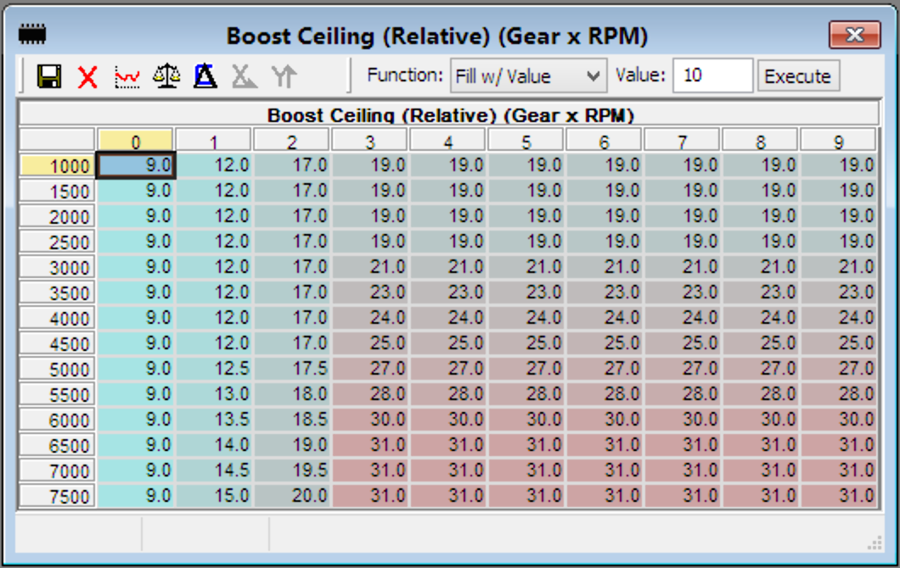
PLATFORM NOTES:
- MSD8x and MG1 DME: the X and Y axis are swapped (and 6 gear rows for N54)

N54 Specific Boost Ceiling Details
Similar to the Antilag Timing “boost target” axis, WGDC Base (Custom) “boost target” axis, and Antilag Boost Target tables, this is a simple table with a lot of tricks going on behind the scenes. On the surface, this table functions as a ceiling to the “boost target” that the DME calculates. However, when used in combination with our 3-cell TMAP scaling table, you can enter the real PSI values you wish to cap / create your boost curve with. All of the scaling is dynamic and handled behind the scenes. There are a few caveats / things to note though:

- If the single cell Boost Ceiling table is left at 1.28bar and you are not using 3-cell TMAP scaling, values greater than ~18psi in this table are treated as 18psi.

- If the single cell Boost Ceiling table is raised to 1.5bar and you are not using 3-cell TMAP scaling, values greater than ~22psi in this table are treated as 22psi.

- When using the 3-cell TMAP scaling with a larger than OEM range (2.5bar) sensor, you should set the single cell Boost Ceiling table to 1.5bar. That keeps that limit out of the way, and lets you enter 0 - Xpsi into this table to create your boost curve per gear, where X is the max boost that you have scaled for in the 3-cell TMAP scaling table. We have included a patch in the XDF that will apply the proper N20 3-cell scaling values to use the full resolution of that sensor. For other sensors, please ensure your math is correct. You can view our post on SpoolStreet for the proper way to go about setting the values in the 3-cell scaling table.

- In order for this table to apply and “cap” your boost curve as desired, you must have a load target which would give a boost target equal to or higher than the table value. You can also raise your load target out of the way.

- All z-data values entered into this table are “relative” psi, and therefore the max value you can utilize from your TMAP will be dependent on your ambient pressure (baro).

- New MHD+ prefixed logging parameters are available to view the dynamically scaled boost parameters.

Custom WGDC Control
In order to make tuning a bit easier (especially on turbo setups not utilizing the OEM wastegate / actuators), we have implemented our own WGDC control scheme and set of tables. Our simplified control scheme is also especially useful when utilizing the Motiv ReFlex to control your boost solenoid, as we broadcast WGDC % over the CANBUS to the ReFlex as part of our 2-way integration. Platform specific implementation details follow below.

N54 Specific Custom WGDC Control Details
To use this control scheme in place of the limited OEM airflow based model, you must set the Enable Custom WGDC Override toggle in the MHD+ Config folder to 01. This activates the tables in the Custom Base Tables > WGDC folder, whose output overrides the near final WGDC output (ECT adder is still applied, as well as battery voltage correction which should remain).
The tables, and their flow, is as follows:
- WGDC Base (Custom) [or WGDC Base (Custom) (Antilag) if antilag is active] is looked up, with axis inputs of RPM and MHD+ Boost Target. Here again, the Boost Target axis is special as described in the boost ceiling section. You can enter actual PSI values up to your 3-cell scaled TMAP maximum. The output of this can be seen when logging the MHD+ WGDC Base parameter.
- WGDC P-Factor (Custom) is looked up, with axis inputs of RPM and MHD+ Boost Error. The Boost error axis here is also special just like the Boost Target axis of the WGDC Base (Custom) table, except it is signed and can have positive or negative values. The output of this table can be seen when logging the MHD+ WGDC P-Factor parameter.
- WGDC D-Factor (Custom) is looked up, with axis inputs of MHD+ Boost Error and MHD+ Boost Error Grad. Both axes here are special just like the Boost Target axis of the WGDC Base (Custom) table, except they are signed and can have positive or negative values. The output of this table can be seen when logging the MHD+ WGDC D-Factor parameter.
- If current Load Actual >= Min Load Threshold for P/D Factors table value, the P and D factors are added to the MHD+ WGDC Base value, which after the OEM ECT adder and batt volt. correction are applied, can be logged as the normal WGDC % Bank 1 / 2.

MG1 Specific WGDC Control Details
To use this control scheme in place of the limited OEM airflow based model, you must set the Enable Custom WGDC Override toggle in the Custom Base Tables > WGDC folder to 01. If you also wish to utilize the Custom P and D factor tables, the other toggle Enable Custom WGDC P and D Factors must be set to 01 as well. The output of the WGDC Base (Custom) table replaces the OEM output of the WGDC Position table (when enabled). The Custom P and D Factors (when enabled) are either added to the output of the custom Base table or the OEM output of the WGDC position table.
The tables, and their flow, is as follows:
- WGDC Base (Custom) [or WGDC Base (Custom) (Antilag) if antilag is active] is looked up, with axis inputs of RPM and boost target. The output of this can be seen when logging the MHD+ WGDC Base parameter.
- WGDC P-Factor (Custom) [or WGDC P-Factor (Custom) (Antilag) if antilag is active] is looked up, with axis inputs of RPM and boost deviation. The output of this table can be seen when logging the MHD+ WGDC P-Factor parameter.
- WGDC D-Factor (Custom) [or WGDC D-Factor (Custom) (Antilag) if antilag is active] is looked up, with axis inputs of boost deviation and boost deviation gradient. The output of this table can be seen when logging the MHD+ WGDC D-Factor parameter.
- If both toggles above are selected, the final WGDC % Bank 1 will now be MHD+ WGDC Base + MHD+ WGDC P-Factor + MHD+ WGDC D-Factor; You can extrapolate this out to the other combinations when either of the toggles is individually selected.

Table Axis Details
- WGDC Base (Custom)
  - RPM x Boost Target (psi, relative)
- WGDC P-Factor (Custom)
  - RPM x Boost Deviation (psi, relative)
- WGDC D-Factor (Custom)
  - Boost Deviation (psi, relative) x Boost Deviation Gradient (psi, relative)

Advanced / Max Effort
The following tables and strategies should only be used on high power builds, typically 1xxx hp and above. While some are technically optional, utilizing them will ensure a much more precise and accurate tune. These tables and features are currently only available for Gen 1/ 2 B58 and S58 vehicles. We will be adding these features to our other platforms very soon!

5 Bar+ Boost Support
If you want to run more than 42-43 psi of boost, you will need a 5 bar map sensor in the pre-throttle / charge pipe location. There is one plug-and-play option available, it is BMW / Bosch part number 13628514488. This is the only 5 bar sensor that can work within the hex limits of the OEM map sensor scaling (gradient) and offset tables.

Sensor Configuration
If you have that sensor, you can simply use the following sensor data in the OEM tables:
- DSVDGRAD: 1000 hPa/V
- DSVDOFS: 0 hPa
If you are using a different 5 bar sensor or a sensor higher than 5 bar, you will need to use our custom MAP sensor scaling, by setting the following:
- Enable Custom MAP Sensor Scaling: 1
- Pre-Throttle MAP Sensor Scaling (Custom): fill with the voltage to pressure curve data provided on the data sheet of the sensor you are using

Enable Increased Boost Ceiling Patch
Lastly, you will also need to enable the logic change that allows targeting these higher boost levels by setting the following:
- Enable Increased Boost Ceiling (5 bar+): 1

MHD+ Load Calculation Config
The OEM models for mass airflow (MAF), load (relative filling), manifold boost, and fueling work very well up until around 30-36 psi (depending on local barometer). Past that (and especially at higher RPM), you start to exceed the maximums for which they were calibrated for and all manner of tuning nuisances can come about.
Rather than hack around these “no longer accurate” models, we instead chose to extend them and continue to utilize an accurate boost -> airflow -> load -> fueling relationship. This means that the Fuel Scalar table can continue to function as a VE adjustment table, and it doesn’t need to be hacked up as a workaround for other maxed models.
There are three possible values for our MHD+ Load Calculation Config byte:
- 0: Disabled, no correction (stock operation)
- 1: Correct Load Actual (relative filling) model
- 2: Correct Load Actual (relative filling) model, and enable Load Reduction Scaling

Correcting Load Actual
Both settings 1 and 2 will apply the appropriate corrections to the mass airflow models and relative filling models, resulting in a much more accurate Load Actual, and in turn much more accurate fuel mass. This removes the need to artificially increase Fuel Scalar. However, with Load Actual now being properly corrected for these higher boost levels, you can and will now run into the DME hex limit of 327% Load Actual. This brings us to setting 2…

Why Load Reduction Scaling?
Setting 2 expands upon setting 1 by also enabling our Load Reduction Scaling table. Ideally, we would have expanded the Load Actual range to go to 655%. However, it is used in thousands of places in the DME which simply makes that not feasible. So the next best option is to allow tuners to selectively scale down your Load Actual curve to keep it lower than the 327% max.
IMPORTANT NOTE:
Any scaled reduction is also automatically accounted for inversely in fuel mass, so overall fueling remains accurate! Just like our advanced PI+ control, this all just works beautifully!
Next, we give details on properly tuning this table.

Properly Tuning Load Reduction Scaling
This table is enabled when MHD+ Load Calculation Config is set to 2. Once enabled, it is active in all map slots as well as FF and FF#2 if they are being utilized.
- X-axis: MHD+ MAF (g/s) (see details in our Advanced Logging Params section below)
- Y-axis: RPM
- Z-data: Load Reduction Factor (1.0 is no reduction)
The goal of tuning this table is to use a reduction factor in the higher MAF column(s) that results in a max of ~310% Load Actual (to allow some wiggle room for elevation / air temp changes). With a flat boost curve and/or static cam timing, this factor will likely need to decrease as RPM increases. However, with a peaking then decreasing boost curve, or with significant overlap changes through your WOT trace, you may only need to decrease the factor around peak torque RPM, and then be able to slowly bump it back up.
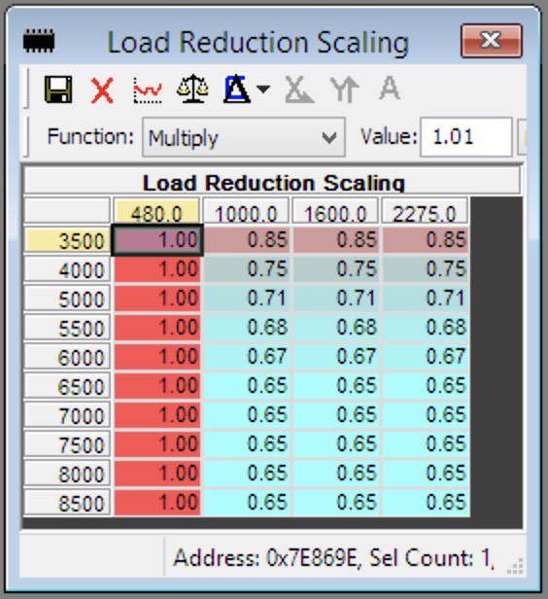
To the left is an example of this table as tested on a 1400 hp fully built G8x. This resulted in a Load Actual curve that peaked and held around 305-310% at 58 psi flat up top.
You may notice that the right three MAF columns are set to use the same reduction. This is because on most setups, simply providing two columns would be sufficient. We wanted to provide the ability to use up to four if some non-linearity was desired.
This allows for some tuning creativity :)

IMPORTANT NOTES:
Any scaled reduction is also automatically accounted for inversely in fuel mass, so overall fueling remains accurate! Also, smoothness of the table z-data is very important, but you can let the natural interpolation between cells work for you.

Advanced Logging Params
The following new parameters are now included to both provide additional data on the extensive additional modeling occurring behind the scenes, as well as aiding in tuning the Load Reduction Scaling on high horsepower builds.
- MHD+ Boost: pre-throttle boost pressure, useful as it can read well past the OEM Boost variable cap of 5 bar absolute, up to 8 bar absolute
- MHD+ Manifold Pressure (Model): intake manifold boost pressure, useful as it can read well past the OEM Boost Mani variable cap of 5 bar absolute, up to 8 bar absolute
- MHD+ MAF: our unique and proprietary MAF calculation (can read up to 2275 g/s, 4x higher than OEM), used in extrapolating and correcting the OEM mass airflow and relative filling models after they max.
- MHD+ Load Reduction Fac: the current output of the Load Reduction Scaling table

Custom Safeties
We set out to develop an easily iterable / expandable format for our custom safeties, and after much testing we feel we’ve achieved it. This will be expanded with new safeties over time, as they are requested or as we find a need. It is being introduced first with our Gen1 B58 MHD+ update, but will soon be available on other platforms as well.

Enable Conditions
There are four high level conditions per safety that must be met first before the input source value is evaluated against the min/max thresholds you define for that safety. These conditions are as follows:
- Enable [X] Safety: this allows you to enable or disable the safety per map slot
- [X] Safety Load Threshold: the safety will only be enabled above this load threshold
- [X] Safety Pedal Threshold: the safety will only be enabled above this pedal threshold
- [X] Safety RPM Threshold: the safety will only be enabled above this RPM threshold
If those conditions are met, the value from input source (see next section), will be evaluated against the minimum and maximum values defined in the [X] Safety Min/Max table.

Input Sources
Each safety has its own configurable input source, which determines the value that is compared against the [X] Safety Min/Max table. This is unique per safety, detailed below.

LPFP Safety
- Set to 0: PI+ LPFP Actual is used (or Reflex Aux Pressure (CAN) if no integrated PI)
- Set to 1: PI+ Diff. Fuel Press is used

Aux 2 Safety
- Set to 0: ReFlex Aux 2 Pressure (CAN) is used
This is intentionally generic, and can be used for things such as Coolant Pressure, Crankcase Pressure, or Exhaust Gas Back Pressure sensor input.

EGT Safety
- Set to 0: ReFlex Bank 1 EGT (CAN) is used
- Set to 1: ReFlex Bank 2 EGT (CAN) is used
- Set to 2: AVG() of ReFlex Bank 1 EGT (CAN) and ReFlex Bank 1 EGT (CAN) is used
- Set to 3: the MIN() of ReFlex Bank 1 EGT (CAN) and ReFlex Bank 1 EGT (CAN) is evaluated against the safety minimum, while the MAX() of the two is evaluated against the safety maximum

Reaction Configuration
Once all enable conditions / thresholds have been met, a reaction delay timer will start. It will increment until the time set in [X] Safety Reaction Delay Time is reached, at which point the configured reaction will be triggered. There are three possible reaction options, configured by setting [X] Safety Reaction Config as follows:
- 0: Apply configured boost / load limits (no CEL)
- 1: Apply configured boost / load limits (with CEL)
- 2: Trigger full MHD+ limp mode (will set DTC code MHD015 with CEL and limp)
For reaction config 0 and 1, you are able to calibrate your own limp condition values using [X] Safety Reaction Load Limit and Boost Limit. For reaction config 2, the default MHD+ limp values of 8psi and 115% Rf are used. Additionally, you can configure a cut to 0% DC for each of the ReFlex Aux outputs during an active safety condition, with table [X] Safety Reaction Disable Aux Outputs.
Lastly, we allow healing of the error conditions (removing the limp after a certain time duration with the safety condition threshold(s) no longer being met, [X] Safety Reaction Heal Time.) If you do not want to allow this, set the heal time to 0.
If MHD+ limp was configured as the reaction, healing will move the DTC code to MHD+ Shadow Codes for historical purposes.

8HP Transmission TCU

Logging Parameters
MHD provides the following logging parameters for the 8HP transmission models currently found in Gen2 B58 and S58 vehicles. Gen1 B58 and more will be supported soon.

- TCU [ xxxx ] Solenoid - Individual solenoid states where 0 = off; 1 = on
  - [ xxxx ] = Clutch A, B, C, D, E
- TCU [ xxxx ] Solenoid Current - Individual solenoid currents (milliamp current applied to each solenoid). These currents directly correlate to pressure (mapped inside TCU). There are no pressure sensors, so everything is modeled based on these currents. They allow you to see how quickly a clutch is oncoming or offgoing.
  - [ xxxx ] = Clutch A, B, C, D, E, TCC, Line Pressure, and Park
- TCU Target Gear - This is the requested gear
- TCU Engaged Gear - This is the current engaged gear. Using this coming with TCU Target Gear, you can get an estimate of the actual shift duration
- TCU Torque Converter Slip (%) - This is the amount of slip that is occurring between the Engine RPM and the Transmission Input Shaft Speed.
  - Note: at low speeds, a jitter of +/- 10% is normal due to parameter scaling
- TCU Clutch Slip (%) - This is the amount of slip that is occurring between the Transmission Input Shaft and the Transmission Output Shaft (correction applied for engaged gear ratio).
  - Note: at low speeds, a jitter of +/- 10% is normal due to parameter scaling
- TCU Transmission Input Speed - The speed of the transmission input shaft
- TCU Transmission Output Speed - The speed of the transmission output shaft
- TCU Transmission Oil Temperature - This is a modeled transmission oil temperature.
  - Note: the 8HP doesn’t have a real temperature sensor for this
- TCU Transmission Mode - Current transmission mode where 0 = Auto; 1 = D/S; 2 = Manual
- TCU Transmission Torque Request Type - The type of transmission torque request
  - 0 = No torque request
  - 1 = Torque increase
  - 2 = Torque reduction
  - 3 = Speed control
  - 4 = Torque limitation
  - 5 = Engine stop request
  - 6 = Creep
  - 7 = TAR_TORQ_CRSH_SLOW torque intervention
  - 8 = Torque reduction with EZA permitted
  - 9 = Torque reduction with EZA prohibited
  - 10 = Relative torque increase
  - 11 = Relative torque reduction with EZA permitted
  - 12 = Relative torque reduction with EZA prohibited
- TCU Torque Converter Status - The status of the torque converter
  - 0 = Full open
  - 1 = Controlled slip (low pressure)
  - 2 = Controlled slip (high pressure)
  - 3 = Closed (low pressure)
  - 4 = Closed (high pressure)
  - 8 = Transition to open
  - 9 = Transition to controlled slip (low pressure)
  - 10 = Transition to controlled slip (high pressure)
  - 11 = Transition to closed (low pressure)
  - 12 = Transition to closed (high pressure)

Real-Time Tuning

For more information on our Real-Time Tuning feature, please check out our companion documentation here:
MHD+: Real-Time Tuning

Locking Tune Files with MHD+ Features

To ensure your customer does not have any issues with your provided *.mhd locked file, first ensure that you are using the latest version of our MHD Map Encryption tool. The current up-to-date version is v6.7. If you need an update, please reach out to us via email.
Next, make sure to update the XDFs used in the locking process with the newly published XDFs containing all the MHD+ table updates from our GitHub. If you have your own XDFs that you customize (separate from our official GitHub publications) that is fine, but you will want to copy over the new MHD+ tables in their entirety to ensure no issues. Additionally, while the existing MHD+ tables are not likely to change, there is a small chance it may be needed, so you would have to clear them from your XDF and re-copy.
Now you should be all set to lock your customer’s file as you normally would.

Revision History

Version | Notes | Date | Updated By
1.00 | Initial creation | 5/13/2021 | Jake Y
1.01 | Image updates, *.mhd file info, antilag turbine I-fac details | 6/16/2021 | Jake Y
1.10 | Added MSD8x, MEVD, MG1 specific details | 6/28/2022 | Jake Y
1.20 | Added Gen2 B58 specifics / updates, knockCEL, advanced ReFlex control and integration, advanced PI control, and custom TCU torque limit strategies | 1/9/2024 | Jake Y
1.30 | Added advanced / max effort details and strategies | 5/31/2024 | Jake Y
1.35 | Update ReFlex integration details for Gen1 B58 | 6/25/2025 | Jake Y
1.36 | Added initial information on custom safeties | 6/27/2025 | Jake Y
1.37 | Added 8HP TCU logging info | 7/24/2025 | Jake Y

